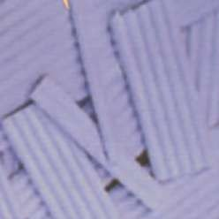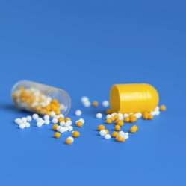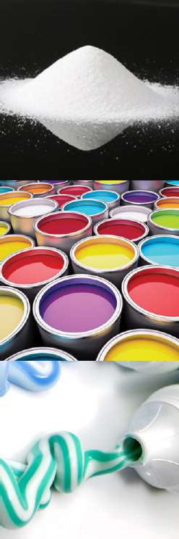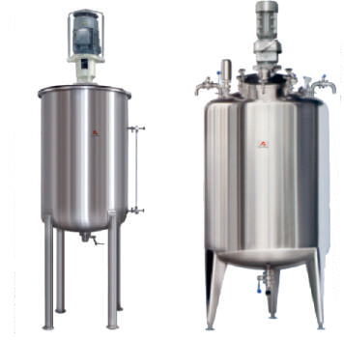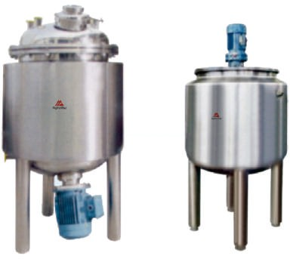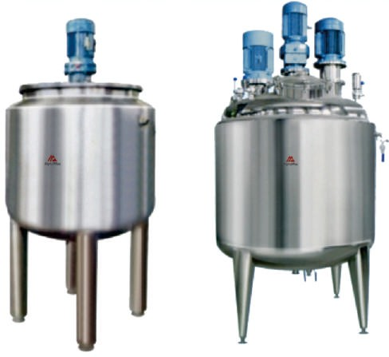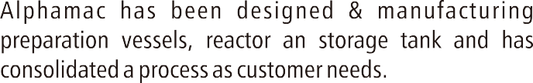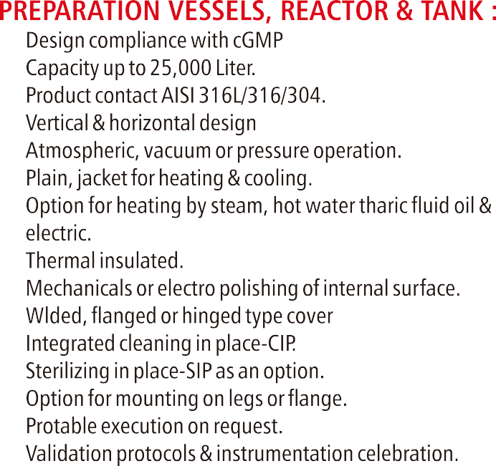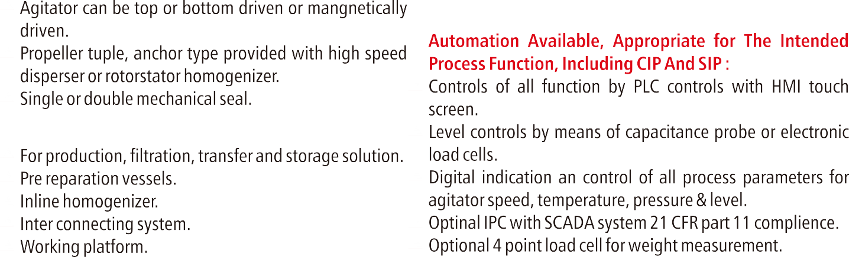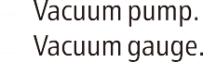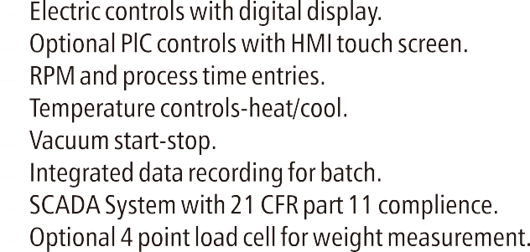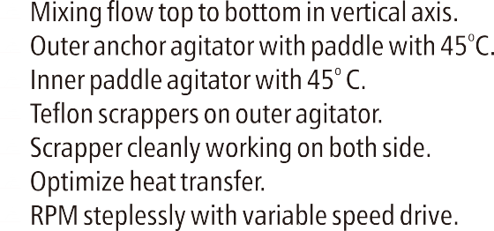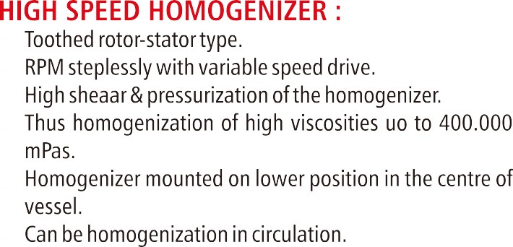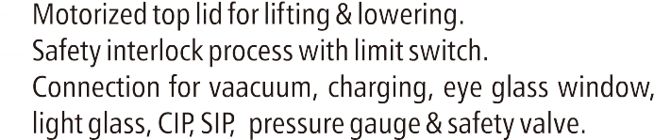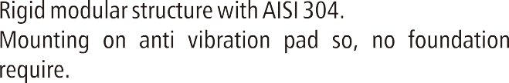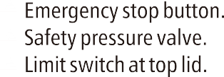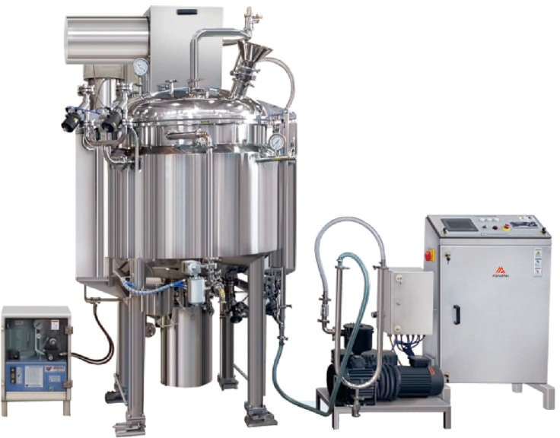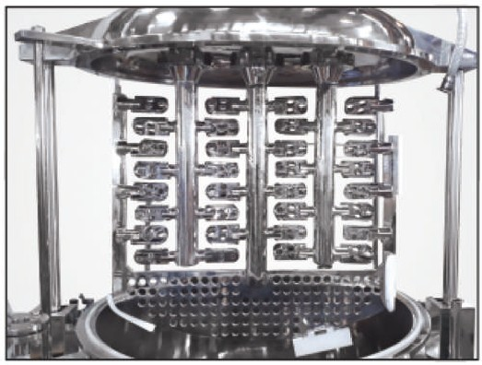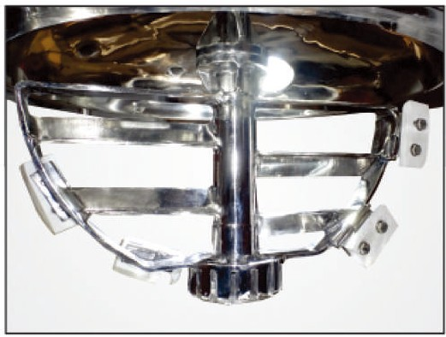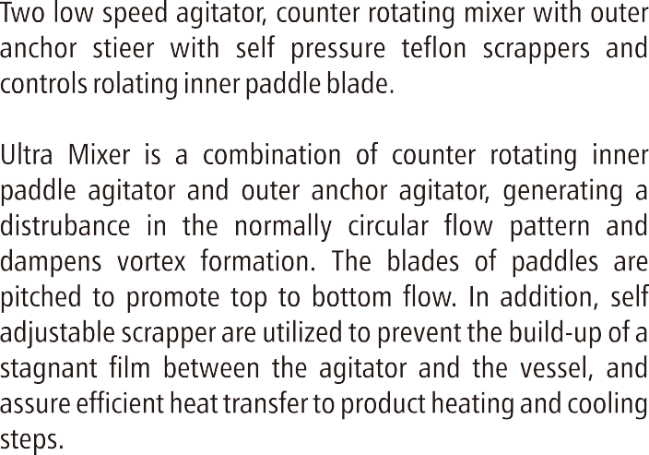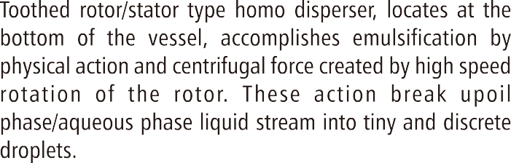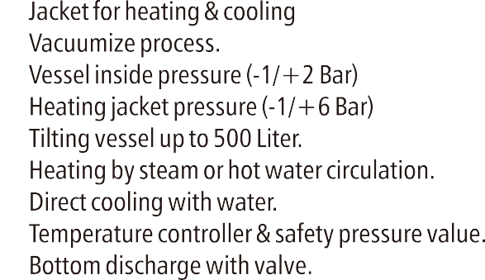

**OINTMENT / CREAM / TOOTH PASTE / GEL MANUFACTURING PLANT**

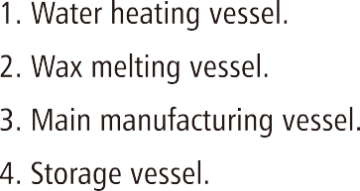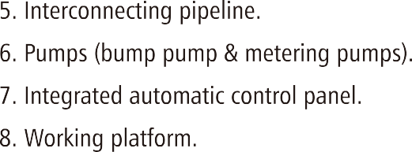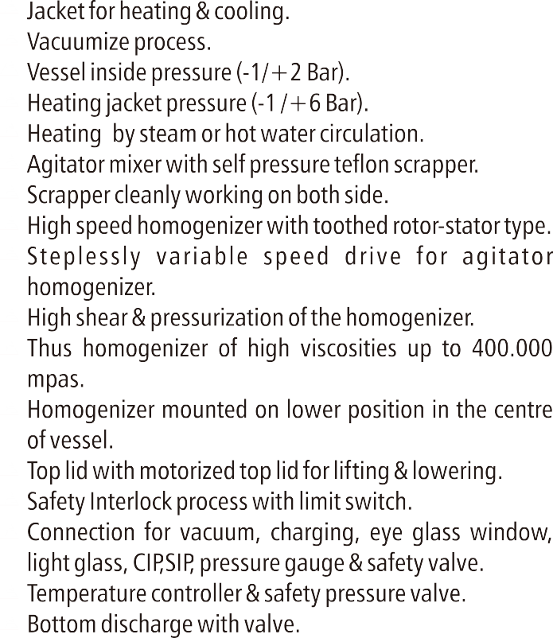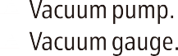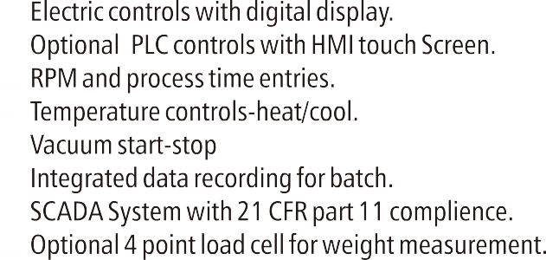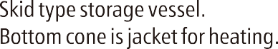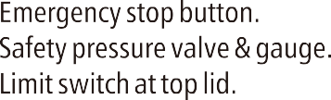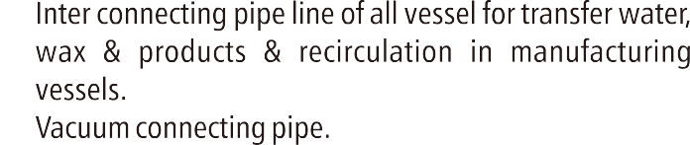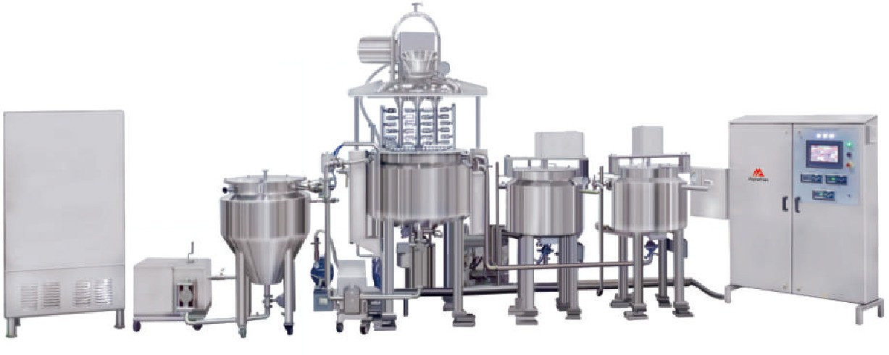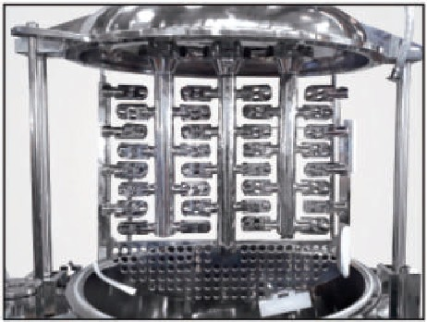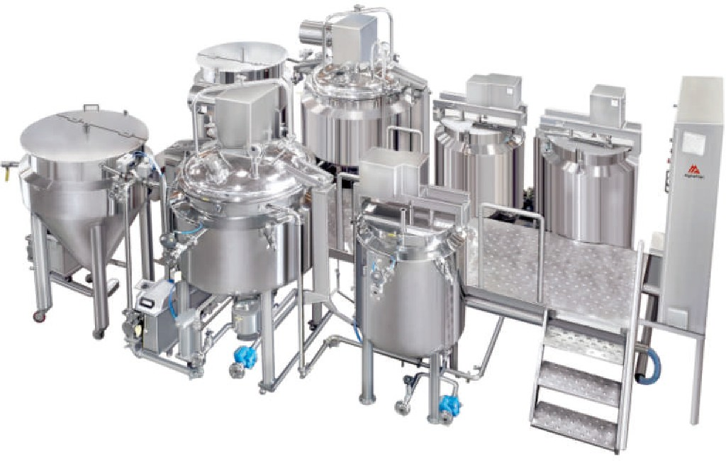

Semi solid manufacturing Plants are ideal tools for the

pharmaceuticals & cosmetics industries for the production of ointment, cream, lotion, gel, tooth paste & emulsions & homogenization.

Fully automatic ointment, cream, tooth paste, gel manufacturing plant consisting of :

Pre Determined water phase vessel. Pre determined oil, wax, petroleum jelly phase vessel. Vacuum homogenizer mixer vessel.

Vacuum pump. Storage vessel. Interconnecting pipeline.

Transfer pumps (bump pump, lobe pump & metering pumps). Integrated automatic control panel.

Working platform.

# DESIGN FEATURES:

Design compliance with cGMP

* Integrated cleaning in place-CIP
* Sterilizing in place-SIP as an option.

# BATCH SIZE:

Available model 50 Liter to 5000 Liter working capacity.

**MATERIALS :**

Product contact AISI 316L. Food grade silicon rubber for seal.

# WATER PHASE VESSEL :

Jacket for heating & cooling. Heating jacket pressure (6 bar). Heating by steam or hot water circulation. Propeller stirring with top mounting.

Temperature controller & safety pressure valve. Bottom discharge with valve.

# WAX PHASE VESSEL :

Jacket for heating & cooling. Heating jacket pressure (4 bar). Heating by steam or hot water circulation. Propeller stirring with top mounting.

Temperature controller & safety pressure valve. Bottom discharge with valve.

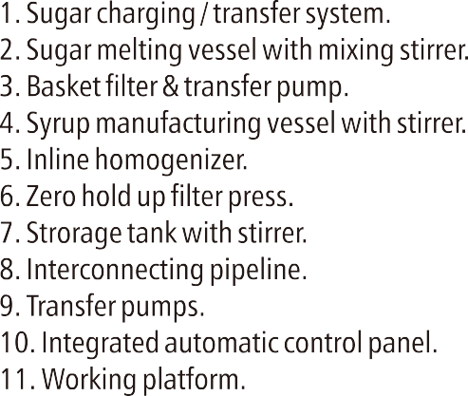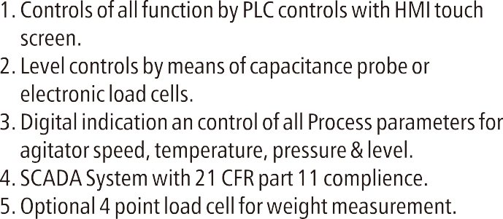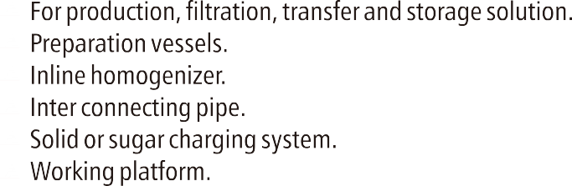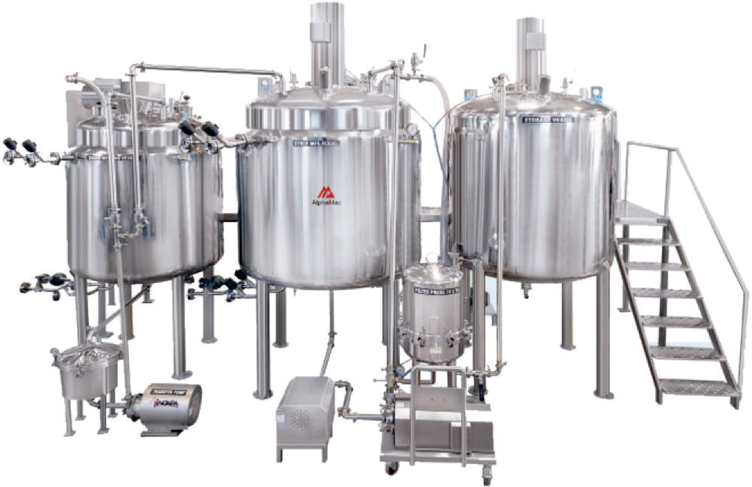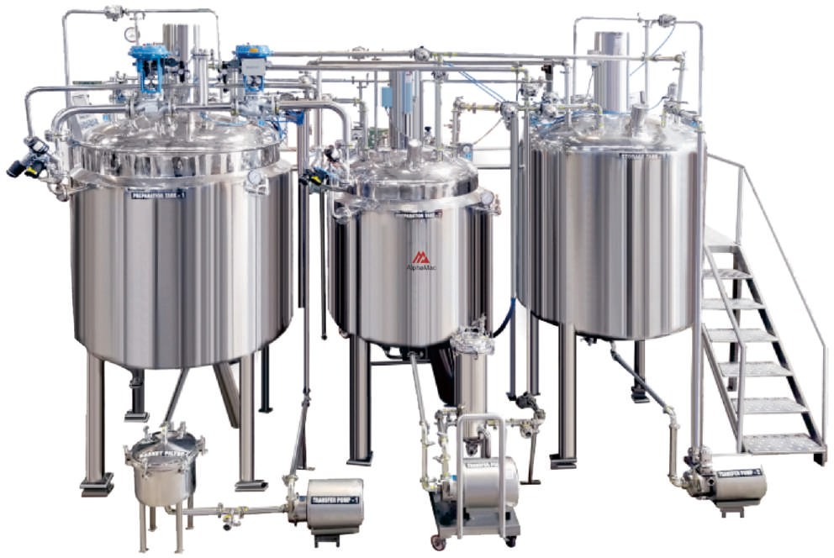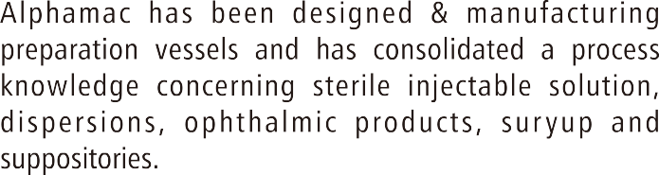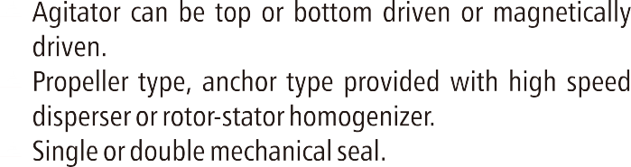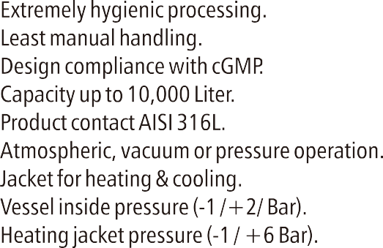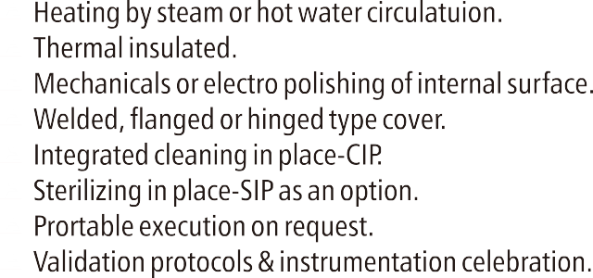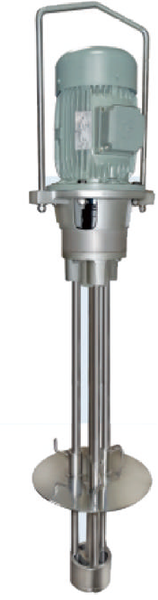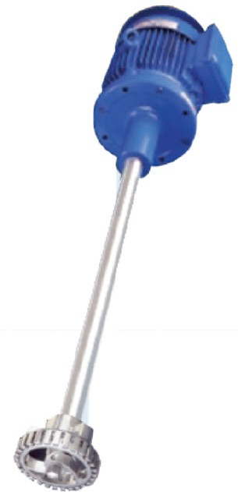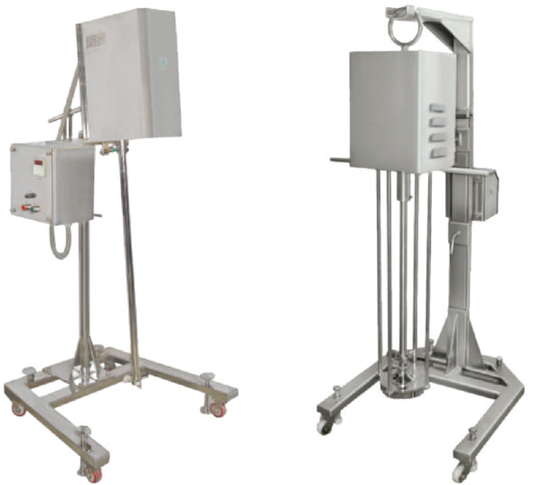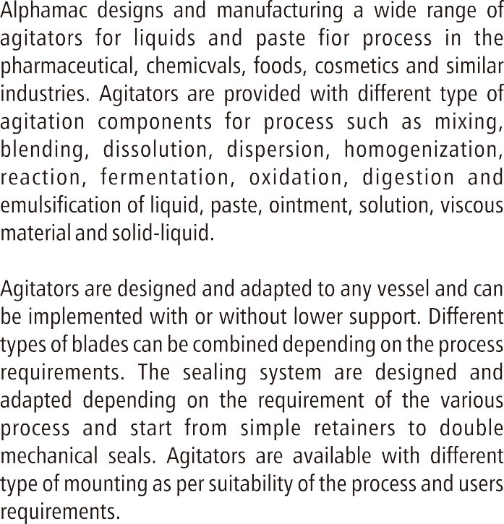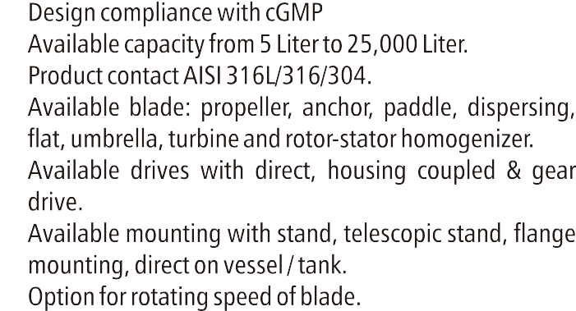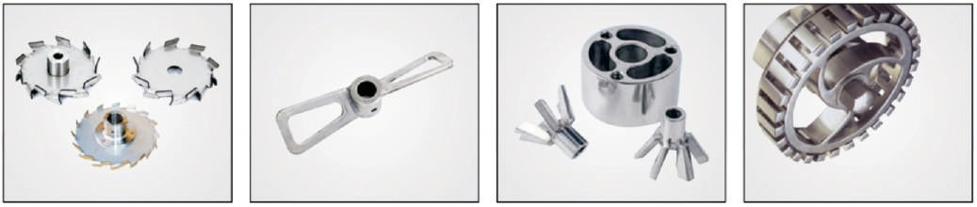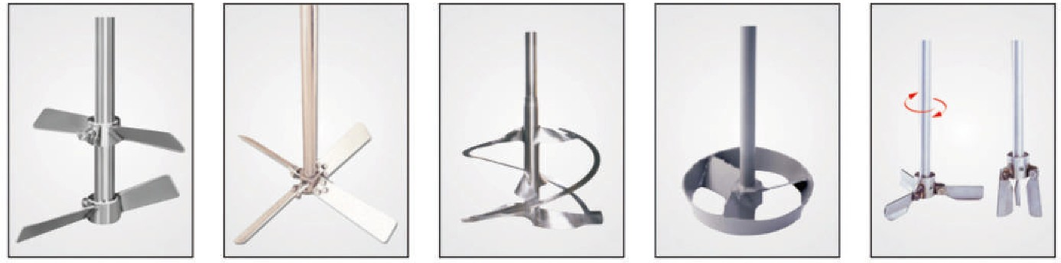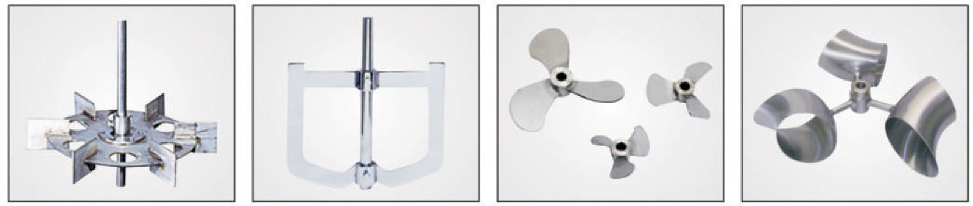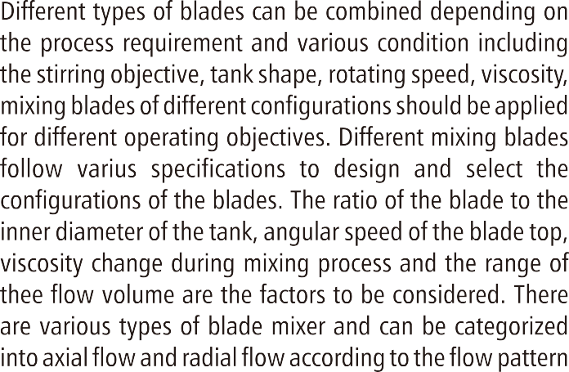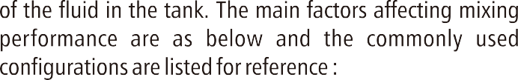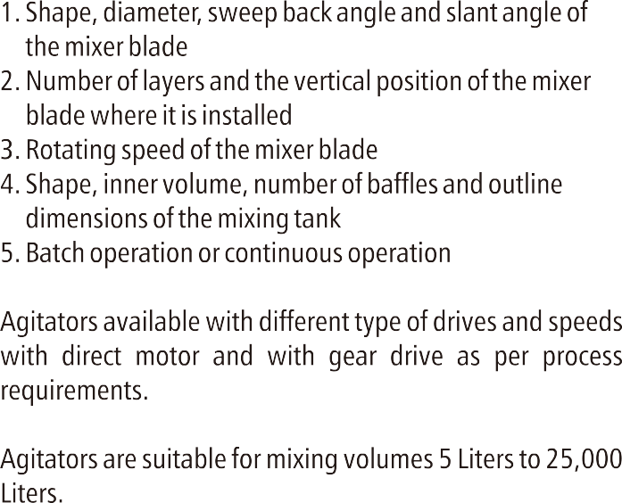

10

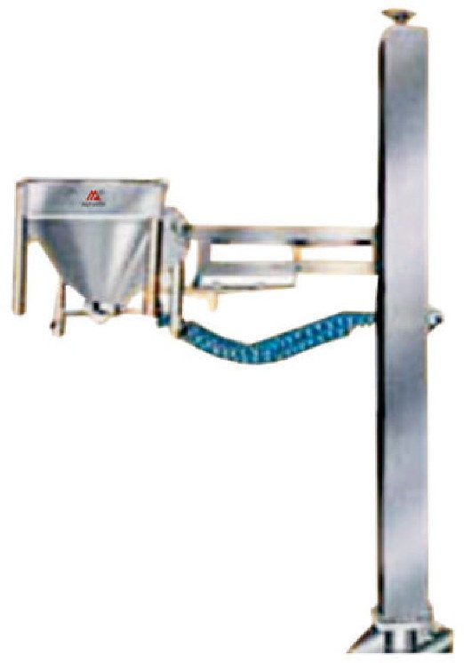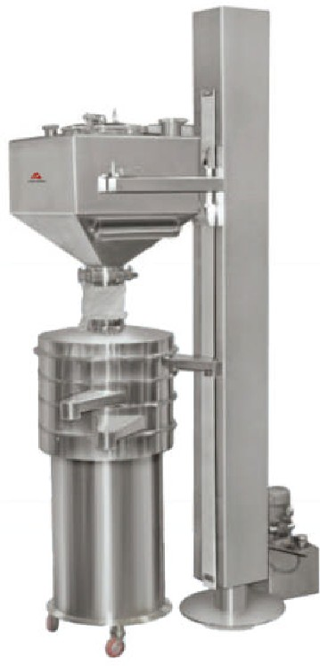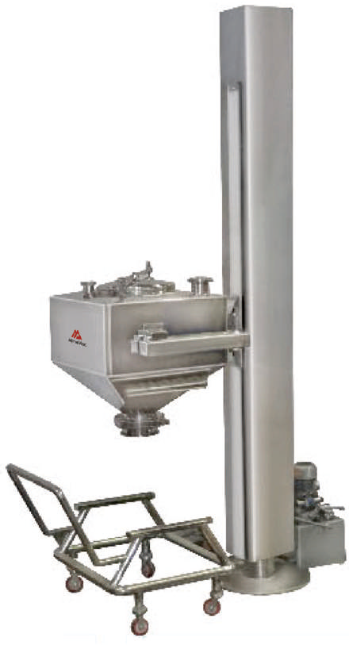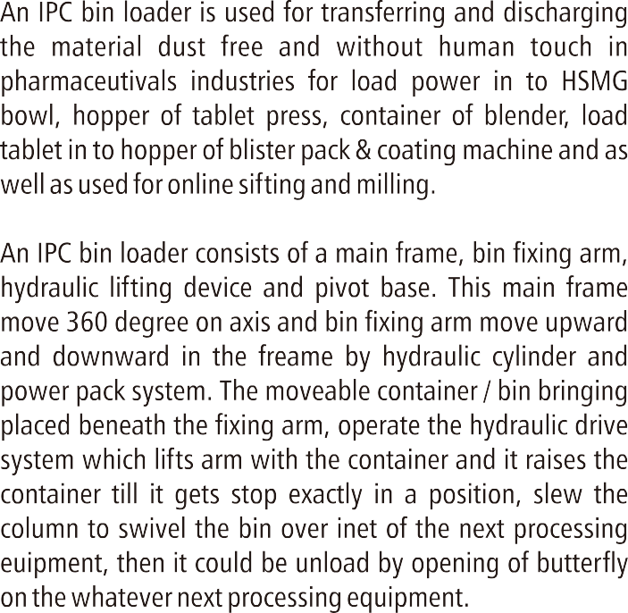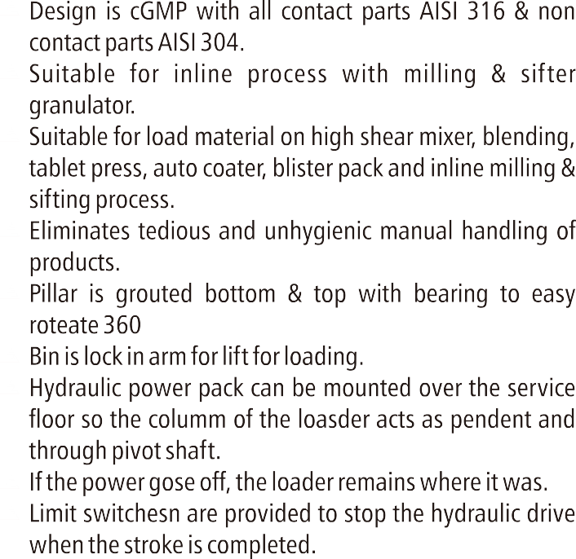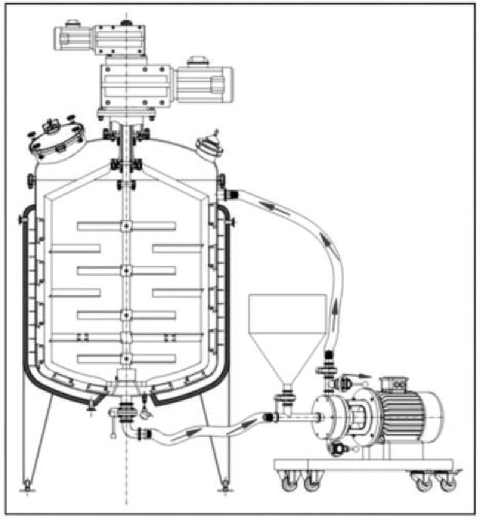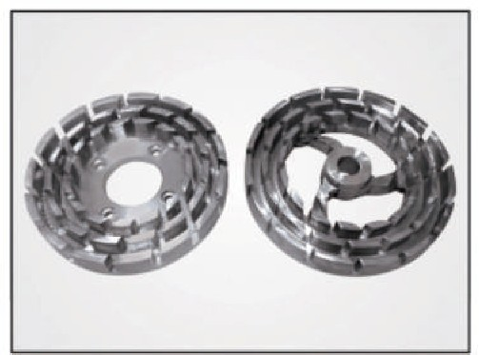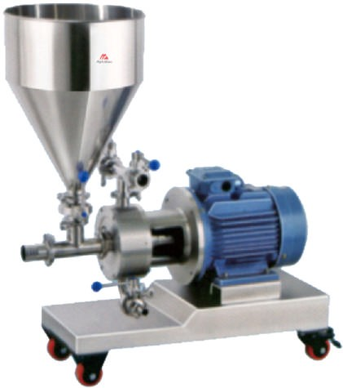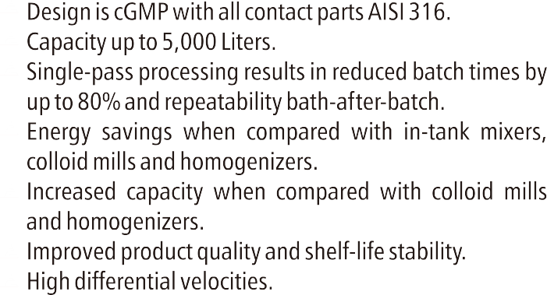

The homogenizer is often necessary to mix one or more substances within a liquid. This device allows to micronized and scatters the particles suspended in the fluid, So that the product become highly stable, no matter the following treatments and stockings the products may undergo. The homogenizer delivers unparalleled consistency and control of high shear process applications such as, immiscible phase emulsifying, homogenizing, wet grinding, texturing, deagglomeration and fine dispersing.

The product arrives to the homogenizing at a low speed and at high pressure (cause by the little gape between the passing head and collision head). Durig the passage the product is subjected to numerous forces which cause the particles micronizatio : a violent acceleration followed by an immediate adeceleration that produces cavitation and then the globules explosion. Strong turbulence united to high frequency vibrations. Collision cutting strengths derived from the lminar passage between the homogenizing valve Surfaces and the following impact with the collision ring.

Incorporating up to single sets of toothed rotor-stator heads, engineered to extremely fine radial tolerances, the emulsifier processes product at high differential velocities, as many as 18 times in a single-pass. The result is consistent, repeatable quality at capacities exceeding those of conventional multiple-pass technology, such as in- tank high-shear mixers, colloid mills and shear pumps.

